**TEST METHOD**

|  |  |
| --- | --- |
| Test Method #: TM-021 | Revision: 01 |
| Title: GRAVITYMODEL_VARIOUSMASS | |

# Revision log

| **Rev.** | **Author** | **Description of revision** | **Date completed** |
| --- | --- | --- | --- |
| 01 | L. Zhao | Initial draft | 2016-01-24 |

**Approval**

|  |  |  |
| --- | --- | --- |
| **Test method approved by** | **Signature** | **date** |
| Name:  Title: |  |  |

# Test description

|  |
| --- |
| **Purpose**  The purpose of this test is to verify the gravity compensator model with robot end effector load with different mass. |
| **Scope**  Auris surgical 7DOF arm MS5/6 |
| **Environmental conditions**  Standard conditions for temperature and pressure. |
| **Equipment, software, tools and other material required**  Robot arm prototype  Small test bench  K.I.T. |
| **Qualifications required**  None. |

# Setup Overview

## Experimental setup

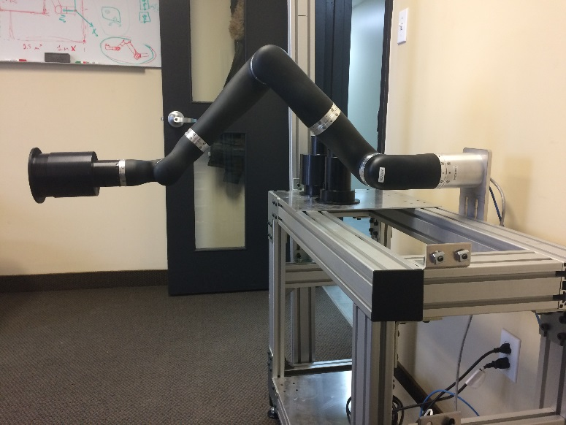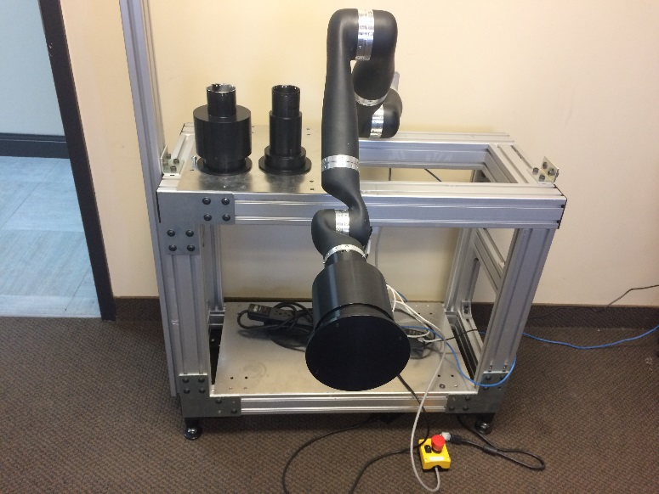Robot is horizontally attached on the test bench, with earth gravity vector aligning with robot base’s -x axis. The z axis of robot base is forward, facing to the user. Three loads are available, with mass 2kg, 3kg and 4kg.

Figure 1 – Test bench overview

## Setup poses

|  |  |  |  |  |  |
| --- | --- | --- | --- | --- | --- |
| **Joint Position**  **(degree)** | **POSE 1** | **POSE X1** | **POSE X2** | **POSE X3** | **POSE Y1** |
| **Joint 1** | 180 | 270 | 270 | 270 | 270 |
| **Joint 2** | 180 | 180 | 90 | 180 | 180 |
| **Joint 3** | 180 | 180 | 180 | 180 | 180 |
| **Joint 4** | 180 | 180 | 180 | 90 | 180 |
| **Joint 5** | 180 | 180 | 180 | 180 | 180 |
| **Joint 6** | 180 | 180 | 180 | 180 | 90 |
| **Joint 7** | 180 | 180 | 180 | 180 | 180 |
|  | C:\Users\lzhao\Dropbox\My Pictures\Photo 2017-01-26, 13 32 57.jpg | C:\Users\lzhao\Dropbox\My Pictures\Photo 2017-01-26, 13 30 35.jpg | C:\Users\lzhao\Dropbox\My Pictures\Photo 2017-01-26, 13 29 55.jpg | C:\Users\lzhao\Dropbox\My Pictures\Photo 2017-01-26, 13 29 39.jpg | C:\Users\lzhao\Dropbox\My Pictures\Photo 2017-01-26, 13 28 34.jpg |

# Test protocol

## Preparation

1. Checkout branches: Keos (Release1.5), rtcontrol (feature/Collisionsing_EEForce), kinova_kinematic (feature/CollisionSensing_VariousMass), thor (feature/CollisionSensing_VariousMass).
2. Launch RT Control on QNX.
3. Launch Nova/Thor on Windows.
4. Connect to robot and go to TM21 window.

## Test process

1. Press “POSE X1” to drive robot to pre-set joint angles and reset torque sensor to zeros.
2. Press “POSE 1” to drive robot to pre-set joint angles and check joint 2, 4, 6.
3. Repeat step 5 and then press “POSE X2” to drive robot to pre-set joint angles and check joint 1.
4. Repeat step 5 and then press “POSE X3” to drive robot to pre-set joint angles and check joint 3.
5. Repeat step 5 and then press “POSE Y1” to drive robot to pre-set joint angles and check joint 5.
6. If necessary, rotate actuator 7 to position that the mass of tool has maximum impact on actuator 7, and check joint 7.
7. Equip robot with 2kg load and repeat steps 5 to 10.
8. Equip robot with 3kg load and repeat steps 5 to 10.
9. Equip robot with 4kg load and repeat steps 5 to 10.

## Notes

1. Result is printed in the rtcontrol terminal, with [sensor torques, computed gravity torques, the errors of them] in each line. There are 7 lines representing data for 7 joints at each moment.
2. The rtcontrol may engage the brake after reaching a pose. This is due to the delay of printing messages in real time process. For our test purpose, this will not cause any problem. Press “start” on the joystick to disable the brake to continue to next pose.
3. With heavy load, it is possible that joint measured torque exceeded the limit (trigger error), but gravity-free torque does not reach the collision threshold.
4. If don’t reset zero torque (step 5) before going to each pose, the repeatability of sensor reading is low, specially when with load.
5. Torque sensor of actuator 2, 4 and 6 should read maximum value at “POSE 1”, the same to actuator 1 at “POSE X2”, actuator 3 at “POSE X3”, and actuator 5 at “POSE Y1”.

## Test results

1. The figure shows the performance of gravity model comparing with the sensor reading of each joint in all test conditions (4 loads × 4 poses). From the figure, we can conclude that, in general, the gravity model well compensated the torques generated by robot link mass at each joint. The worst cases happens at actuator 2, and its causes is discussed in the following content.

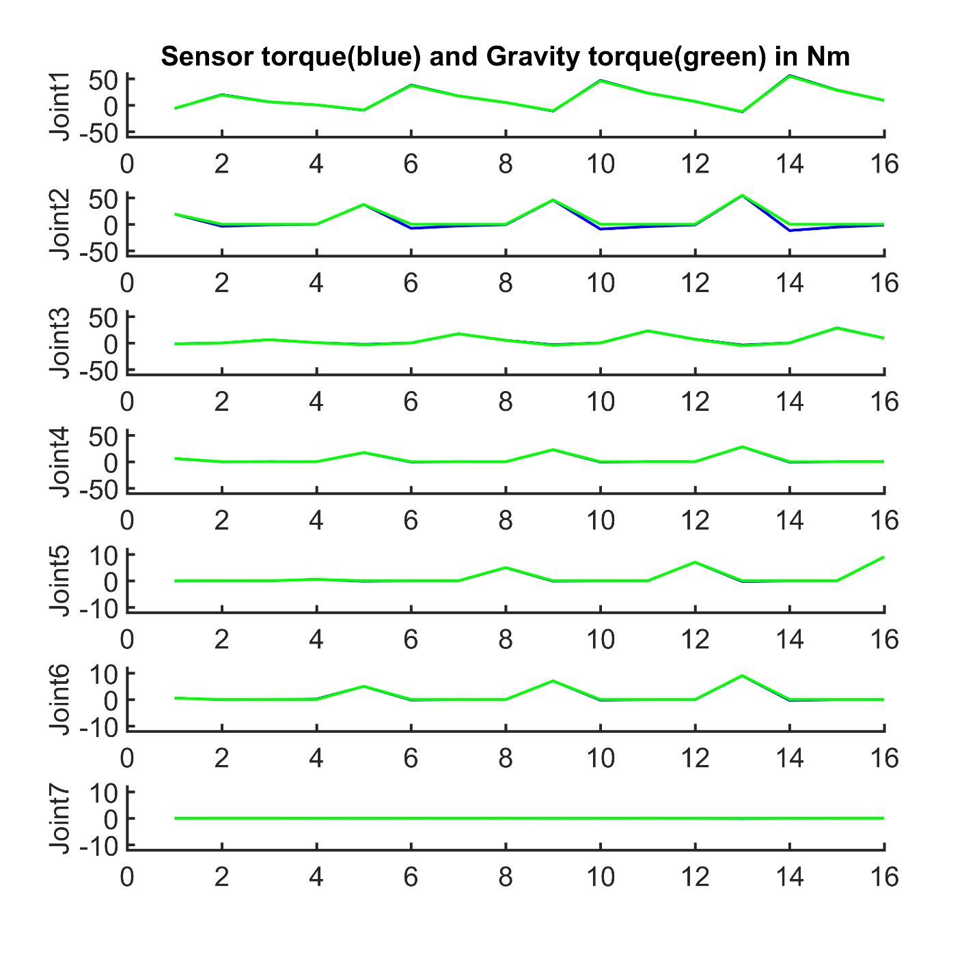

1. The table below shows the maximum value of gravity-free torque (error of sensor torque and gravity torque) of each joint in different loads. It is easy to conclude that the error is proportional to the robot load. As mentioned before, we again saw that gravity model has the worst performance at Joint 2.

|  |  |  |  |  |  |  |  |
| --- | --- | --- | --- | --- | --- | --- | --- |
|  | **Joint 1** | **Joint 2** | **Joint 3** | **Joint 4** | **Joint 5** | **Joint 6** | **Joint 7** |
| **No Load** | 0.6605 | 3.7953 | 0.3615 | 0.1364 | 0.0747 | 0.1498 | 0.0312 |
| **2kg Load** | 0.8195 | 7.6916 | 0.7851 | 0.4796 | 0.162 | 0.1701 | 0.0484 |
| **3kg Load** | 0.8865 | 9.1544 | 0.938 | 0.6317 | 0.143 | 0.2142 | 0.0682 |
| **4kg Load** | **1.2767** | **11.9404** | **1.1109** | **0.8544** | **0.2616** | **0.3337** | **0.1169** |

1. The table below shows the maximum value of gravity-free torque (error of sensor torque and gravity torque) of each joint in different poses. According to the table, each joint has worst condition either in POSE 1 or POSE 2. At POSE 1, gravity has most impact to joint 2, 4 and 6 along its rotation axis (z axis of joint frame). Thus, the errors of torque sensor at joint 1, 3, 5 and 7 are mainly due to the cross-torque effect on the torque sensors (x or y axis of joint frame). The similar case happened at POSE X2, where theoretically no torque should be applied along rotation axis at joint 2, 4 and 6. All errors demonstrated in the table are coming from the false reading of the torque sensor. Especially for joint 2, we can see that the cross-torque effect contributes about 12Nm to the false reading.

|  |  |  |  |  |  |  |  |
| --- | --- | --- | --- | --- | --- | --- | --- |
|  | **Joint 1** | **Joint 2** | **Joint 3** | **Joint 4** | **Joint 5** | **Joint 6** | **Joint 7** |
| **POSE 1** | 0.4437 | 0.2328 | **1.1109** | 0.1413 | **0.2616** | 0.0274 | **0.1169** |
| **POSE X2** | **1.2767** | **11.9404** | 0.131 | **0.8544** | 0.0274 | **0.3337** | 0.0303 |
| **POSE X3** | 0.3262 | 5.3102 | 0.2684 | 0.1603 | 0.0276 | 0.0311 | 0.0126 |
| **POSE Y1** | 0.0934 | 1.5243 | 0.0987 | 0.1302 | 0.0215 | 0.1498 | 0.0306 |

# Measurements and acceptance criteria

The gravity compensated joint torque should be small, if the both gravity model and torque sensor reading is functioning well.

# Conclusion

The gravity model well presents the mass impact on each joint. However, the performance of gravity compensator varies due to the fault sensor reading. The robot load will degrade the performance in an acceptable range. In different robot configurations, the cross-torque effect varies a lot and this is the major issue to be considered. If the cross-torque effect can be analysed and modelized, the gravity compensator will be greatly improved.

# Form revision log

| **Rev.** | **DCO #** | **Description of revision** | **Author** |
| --- | --- | --- | --- |
| 01 | DCO_2016-001 | Initial draft | Jean-Yves Pairet |